Project Name: Virtual Key for Repositories

Developer Details:-

Name: Korivi Edukondalu

Designation: Java Developer

Company: Trainee in Simplilearn

Mail id: [sunriser.7hills@gmail.com](mailto:sunriser.7hills@gmail.com)

GitHub Link: https://github.com/7hillsk/Virtual-Key-for-Repositories-in-Simplilearn-Phase-1-Project

Source Code in Development Part:-

package simpleLearn.Phase2Project;

import java.io.File;

import java.io.IOException;

import java.util.Arrays;

import java.util.Scanner;

public class VirtualKey {

public static void main(String[] args) throws IOException {

// Display Welcome Screen By given problem statement (Lockedme.com).

// Given Developer Details also mention Here.

System.out.println("\*\*\*\*\*\*\*\*\*\*\*\*\*\*\*\* Welcome to Lockedme.com \*\*\*\*\*\*\*\*\*\*\*\*\*\*\*\*\*\*\*\*\*\*\*\n" +

"Application Name: Virtual Key Repository\n" +

"\*\*\*\*\*\*\*\*\*\*\*\*\*\*\*Developer Details\*\*\*\*\*\*\*\*\*\*\*\*\*\*\*\n" +

"Name: KORIVI EDUKONDALU \n" +

"Designation: JAVA Developer\n" +

"Date: 01-07-2022");

// we create Some Multiple choices for user convenience

while (true) {

System.out.println("Enter 1 : Get file names in ascending order\n" +

"Enter 2: For Business Level Operation\n" +

"Enter 3: Close the Application");

System.out.println("Please Select any one given above options :");

// we take input dynamically from user end here.

Scanner s = new Scanner(System.in);

int option = s.nextInt();

// The Existing and add new files are arranged in Sorting order by Using list and Arrays concepts in Collections

if (option == 1) {

// To create Directory/Folder in Local System

File f3 = new File("LockedMe Digital Files");

f3.mkdir();

File file1 = new File("D:\\ESIC\\DEV\\Phase 2 Projects\\SimpliLearn\\FirstClass\\LockedMe Digital Files");

if(file1.isDirectory())

{

if(file1.list().length>0)

{

System.out.println("..................................................");

System.out.println("The All files are in Assending order ");

File file = new File("D:\\ESIC\\DEV\\Phase 2 Projects\\SimpliLearn\\FirstClass\\LockedMe Digital Files" );

String[] children = file.list();

Arrays.sort(children);

for (int i = 0; i< children.length; i++) {

String filename = children[i];

System.out.println(filename);

}

System.out.println("..................................................");

}

else

{

System.out.println("..................................................");

System.out.println("Sorry the Directory/Folder is Empty");

System.out.println("..................................................");

}

}

}

// We are Doing Business Operations Here ..........

else if (option == 2) {

System.out.println("Enter 1 : add a new file\n" +

"enter 2: Delete Existing file\n" +

"enter 3: Search file in Directory\n" +

"enter 4: Go back Main Menu");

System.out.println("Please Select any one given above options :");

int input = s.nextInt();

switch (input) {

// we are doing Create a new file functionality

case 1:

System.out.println("..................................................");

System.out.print("Enter How many files you want to create ?\n");

int n=s.nextInt();

for(int i=0;i<n;i++) {

System.out.println("Enter your file name");

Scanner scanner1 = new Scanner(System.in);

String name = scanner1.nextLine();

File file6 = new File("D:\\ESIC\\DEV\\Phase 2 Projects\\SimpliLearn\\FirstClass\\LockedMe Digital Files\\"+ name);

if (file6.createNewFile()) {

System.out.println("File is created sucessfully");

System.out.println("After Create a new file, The Total files in Existing Directory ");

File file = new File("D:\\ESIC\\DEV\\Phase 2 Projects\\SimpliLearn\\FirstClass\\LockedMe Digital Files" );

String[] children = file.list();

Arrays.sort(children);

for (int j = 0; j< children.length; j++) {

String filen = children[j];

System.out.println(filen);

}

} else {

System.out.println("File is already exist");

}

System.out.println("..................................................");

}

break;

// we are doing delete existing file in directory.

case 2:

System.out.println("..................................................");

System.out.println("Enter file name for delete");

Scanner scanner2 = new Scanner(System.in);

String name1 = scanner2.nextLine();

File file2 = new File("D:\\ESIC\\DEV\\Phase 2 Projects\\SimpliLearn\\FirstClass\\LockedMe Digital Files\\"+ name1);

if(file2.delete())

{

System.out.println("File is Successfully deleted");

System.out.println("After Delete file, The Remaining files in Existing Directory ");

File file = new File("D:\\ESIC\\DEV\\Phase 2 Projects\\SimpliLearn\\FirstClass\\LockedMe Digital Files" );

String[] children = file.list();

Arrays.sort(children);

for (int i = 0; i< children.length; i++) {

String filen = children[i];

System.out.println(filen);

}

}

else

{

System.out.println("File is not deleted or file is not found");

}

System.out.println("..................................................");

break;

// we are doing search a file in Directory

case 3:

System.out.println("..................................................");

System.out.println("Enter your file name to search");

Scanner scanner3 = new Scanner(System.in);

String fileName3 = scanner3.nextLine();

File file3 = new File("D:\\ESIC\\DEV\\Phase 2 Projects\\SimpliLearn\\FirstClass\\LockedMe Digital Files\\"+ fileName3);

if(file3.isFile())

{

System.out.println("File is available in this Directory ");

}

else {

System.out.println("File is not available In this Directory");

}

System.out.println("..................................................");

break;

// Otherwise we will goto Main Menu

case 4:

System.out.println("GoBack to Main Menu");

break;

default:

System.out.println("Please choose valid option ");

}

}

if (option == 3){

System.out.println("you have Exited successfully");

System.out.println("................Thank you.....................");

System.exit(option);

}

}

}

}

Execution Part:-

1.Directory created But Directory is Empty:-

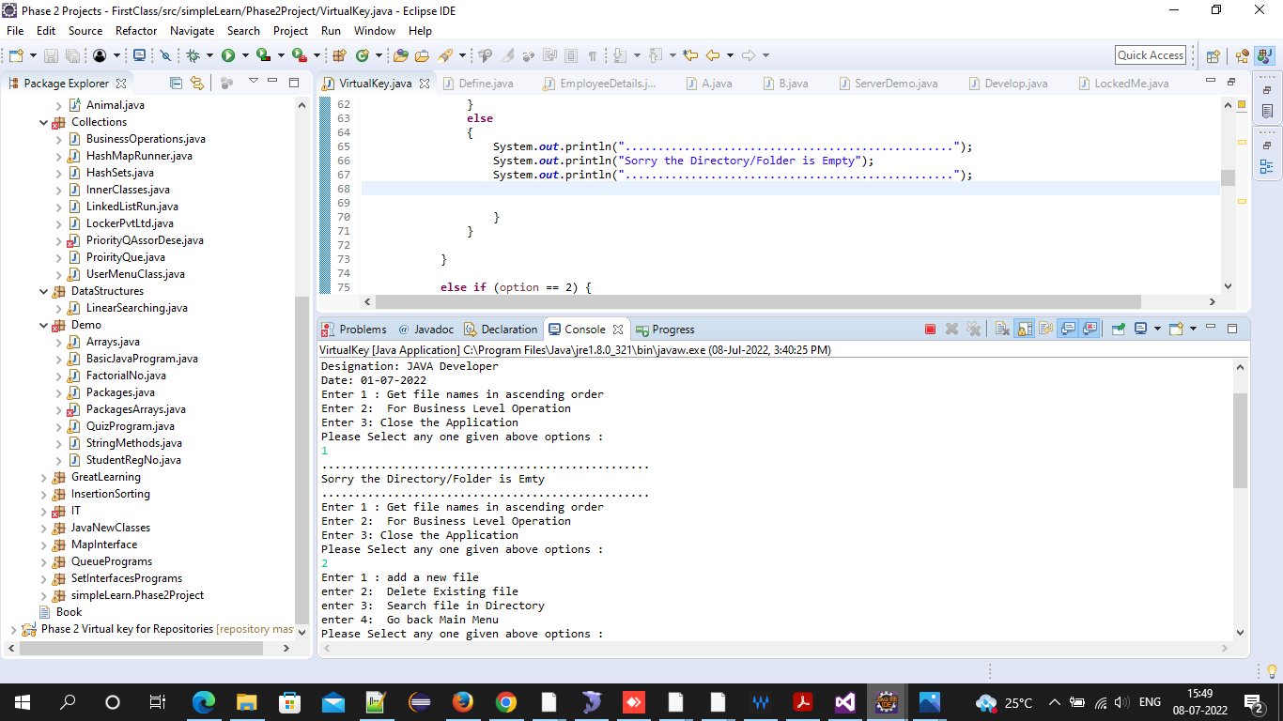

2.Add files in Directory:-

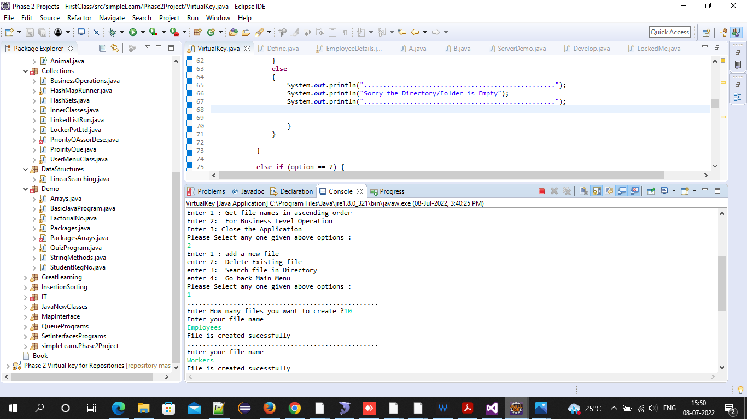

3.Files in Ascending order:-

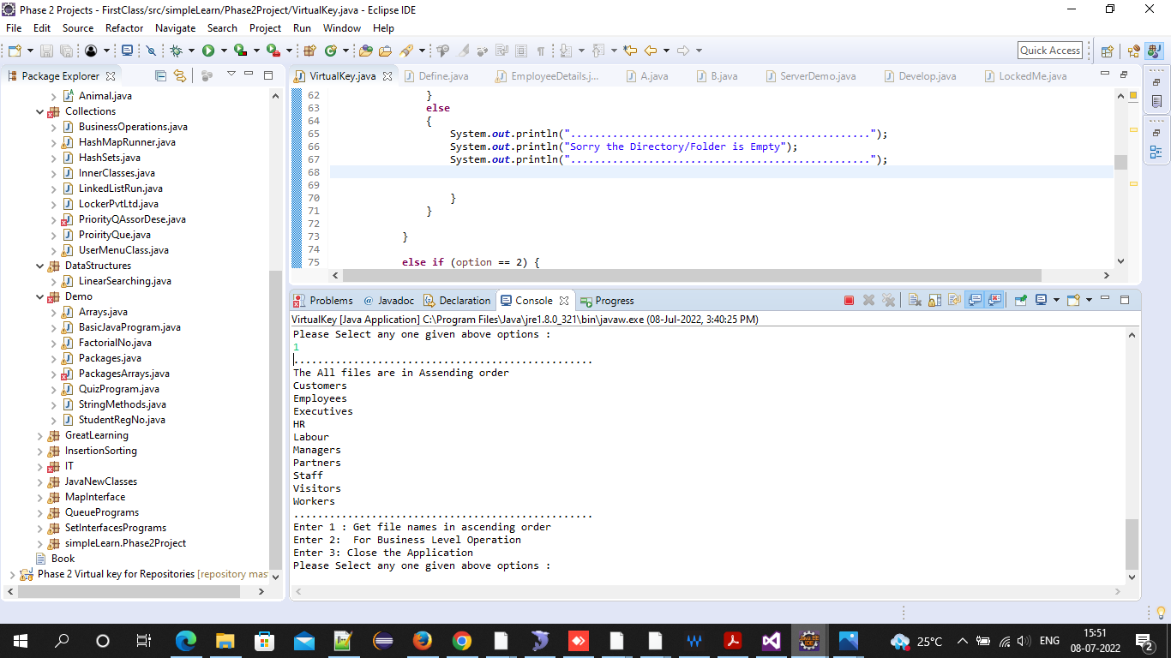

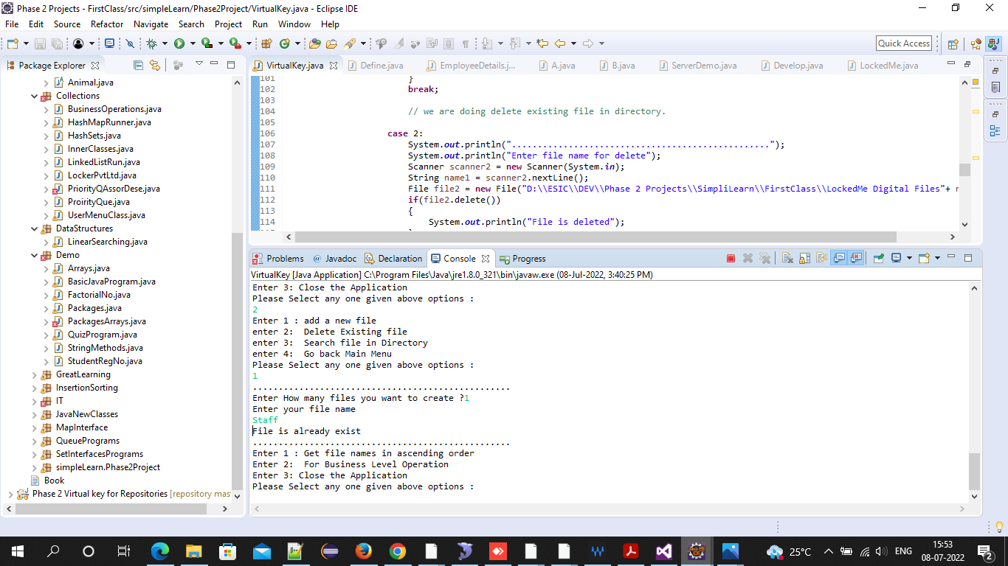

4.Delete Files in Directory:-

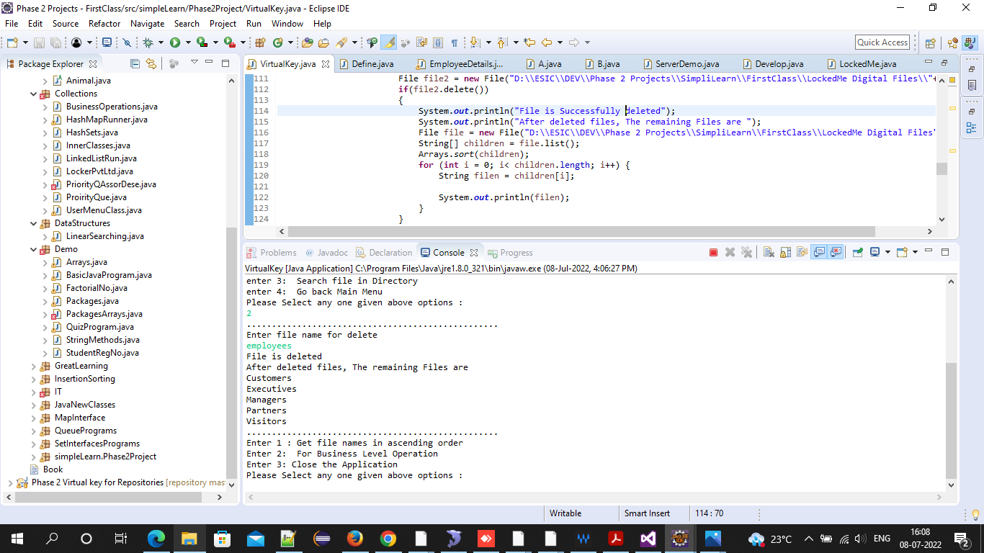

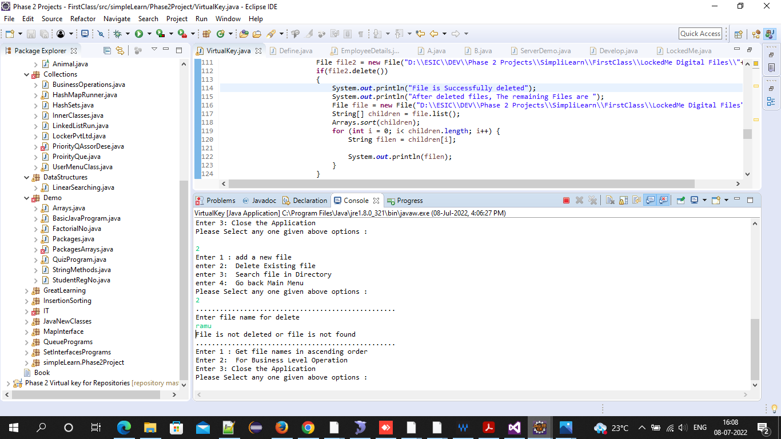

5.Searching files in a Directory:-

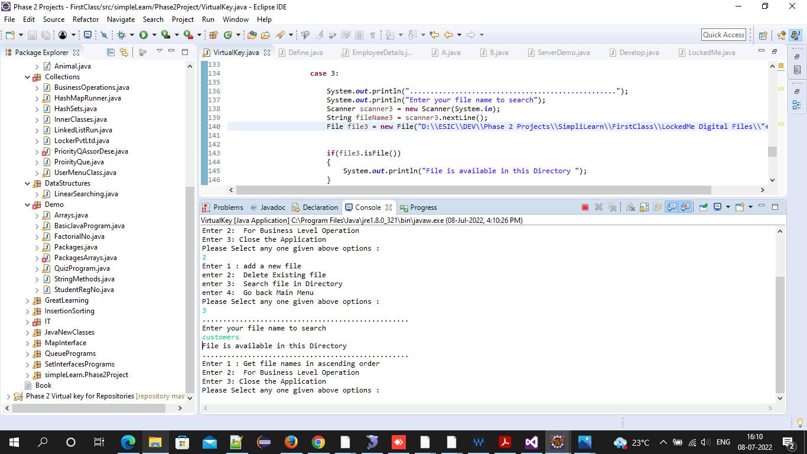

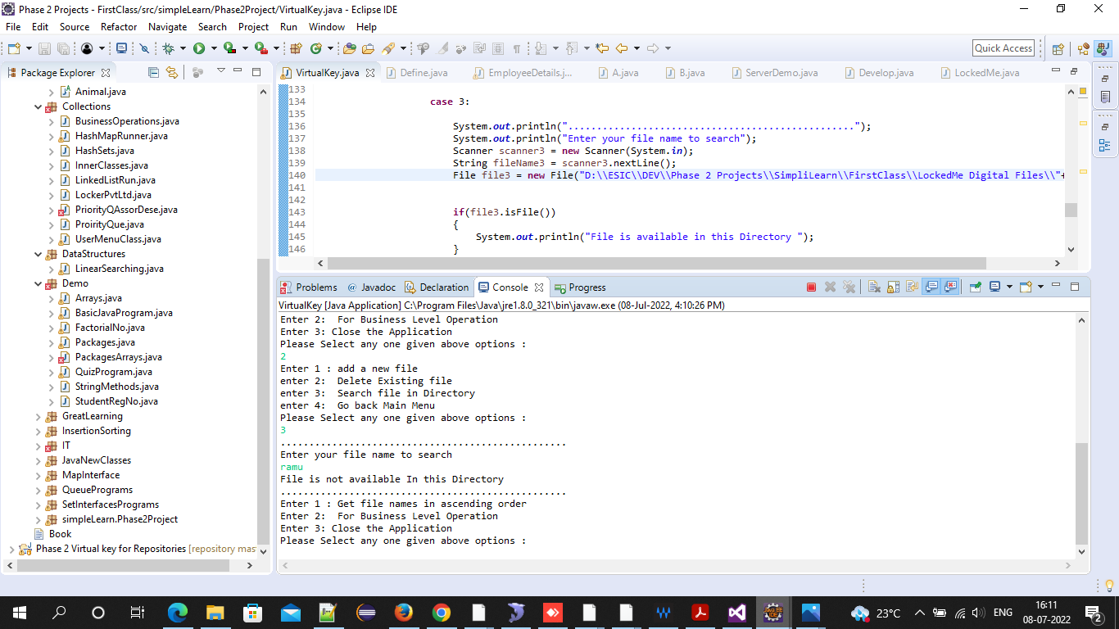

7. Default options like Exit:-

